Table of Contents

INTRODUCTION: 3

AIM: 3

THEORY: 3

Stress: Mohr’s Circle 3

Double Refraction 3

Polariscope: Wave Plate, Polarizer and Analyser 3

Retardation Plates 4

Fringes 4

Isochromatic Fringes 4

Isoclines Fringes 4

Normal and Polarised Light 4

Principles of Photoelasticity 5

The Stress Optics Law 5

Equipment And Specifications: 6

Fixing of Model 6

Linear and Circular Polariscope 6

Monochromatic Sodium Light 7

Makrolon Model 7

Force Gauge or Spring Scale 7

Observations: 8

Abaqus 8

Comparision With Theory: 10

Conclusion And Discussion: 10

Additional Discussion: 11

Isotropic and Anisotropic Materials 11

Jones Vector and Matrix 11

Measuring Techniques: 11

Refrences: 12

# INTRODUCTION:

Transparent noncrystalline materials, initially optically isotropic, become anisotropic under stress, showing induced birefringence proportional to the applied stress. This helps study stress patterns in transparent models. Viewing under white light reveals colorful fringes, while monochromatic light clarifies dense areas. Photoelasticity is widely used in silicon wafer stress analysis, rapid prototyping, and fiber optic sensor development, with stress fields visualized using photosensitive materials between crossed polarizing filters.

# AIM:

To analyse the stress distribution pattern of a specimen using a photoelasticity setup.

# THEORY:

### Stress: Mohr’s Circle

**Stress** is the internal force per unit area in a material. **Normal stress** (σ) acts perpendicular to a surface, either tensile (pulling) or compressive (pushing). **Shear stress** (τ) acts parallel, causing layers to slide. **Principal stresses** are the maximum and minimum stresses at a point, with zero shear stress, denoted as σ₁ (maximum), σ₂ (minimum in 2D), and σ₃ (intermediate in 3D). **Mohr’s Circle** graphically represents the relationship between normal and shear stresses to calculate principal and maximum shear stresses. Normal stress is plotted horizontally, shear stress vertically, with the center at (σx + σy)/2. The radius RR is ((σx−σy)/2)2+τxy2, and horizontal intersections show principal stresses σ₁ and σ₂. Maximum shear stress is (σ₁−σ₂)/2. Mohr’s Circle aids in stress analysis for material and structural design.

### Double Refraction

Birefringence occurs when light enters an anisotropic material, splitting into two rays—the ordinary (o-ray) and extraordinary (e-ray)—which travel at different speeds due to the refractive index difference (ne−no). Uniaxial crystals have one optic axis, while biaxial crystals have two. This effect is used in polarizing microscopes, wave plates, polarizers, and stress analysis, causing images viewed through birefringent crystals to appear doubled.

### Polariscope: Wave Plate, Polarizer and Analyser

A **Polariscope** is an optical instrument used to analyze polarization and stress distribution in transparent materials based on **photoelasticity**. Applied stress induces birefringence, altering optical properties. A **polarizer** filters light, allowing only aligned electric field components to pass, following **Malus's law**. **Wave plates** (quarter-wave and half-wave) introduce controlled phase shifts, altering polarization states. An **analyzer** (second polarizer) examines light emerging from the sample, with intensity variations revealing stress-induced birefringence.

### Retardation Plates

**Retardation plates** (quarter-wave and half-wave), made from birefringent materials like **quartz** or **mica**, control phase shifts and are essential for precise stress analysis.

### Fringes

In a polariscope, fringes are alternating dark and light bands formed when polarized light interacts with stressed transparent materials. These patterns result from birefringence, where internal stress alters the material's refractive index, visually representing stress distribution. These fringes arise from interference as polarized light splits into components traveling at different speeds through the stressed material.

### Isochromatic Fringes

Isochromatic fringes are color patterns formed when polarized light interacts with stressed birefringent materials in photoelasticity. Variations in stress cause changes in the refractive index, splitting light into orthogonal components that travel at different velocities. Their interference creates colored bands, each representing specific stress differences (σ1−σ2) within the material. The fringe order increases with stress magnitude, offering a quantitative measure of stress distribution.

### Isoclines Fringes

Isoclinic fringes in photoelasticity, observed under a polariscope, indicate regions where the directions of maximum and minimum principal stresses remain constant. These dark lines result from polarized light interacting with the material’s birefringence. Unlike isochromatic fringes that show stress magnitude, isoclinic fringes reveal stress orientation. Combined with isochromatic fringes, they enable detailed stress analysis for optimizing material and structural design.

### Normal and Polarised Light

Normal light consists of waves vibrating in multiple planes perpendicular to the direction of propagation, emitted by sources like the sun and bulbs. The electric field oscillates randomly but remains perpendicular to the travel direction. Polarized light, in contrast, oscillates in a single plane, achieved by filtering unpolarized light. It includes linear, circular, and elliptical polarization, produced by polarizing filters, reflection, or birefringence. Polarized light is used in reducing glare, enhancing display clarity, and in scientific applications like stress analysis. The main difference is that normal light vibrates in multiple planes, while polarized light vibrates in one.

### Principles of Photoelasticity

Photoelasticity is based on the observation that transparent materials change their optical properties under stress, becoming birefringent and splitting light into two rays with different velocities. When placed under polarized light, the material creates colorful fringes that represent stress distribution. Engineers use these patterns to analyze the intensity and distribution of stresses within materials, commonly applying this technique in experimental mechanics for stress analysis.

### The Stress Optics Law

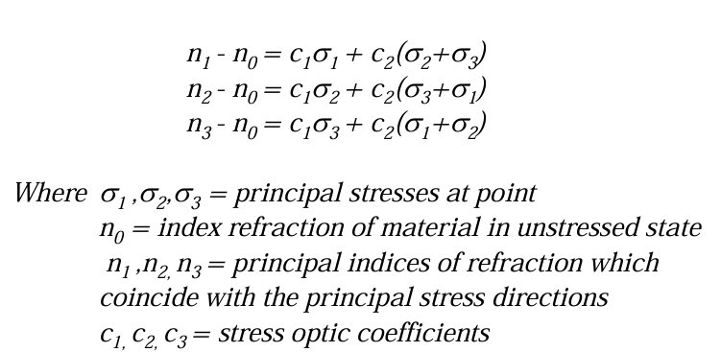Maxwell proposed that indies of refraction were linearly proportional to the loads thus to stresses or strains for a linear elastic material. The relationship:

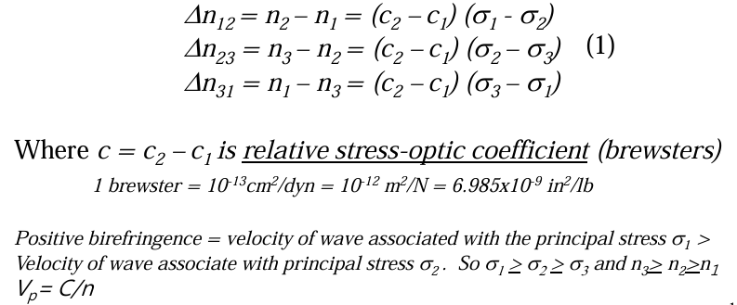The equation indicates complete state of stress can be determined by measuring the three principle indices of refraction and establishing the direction of three principle axes. In photoelasticity, relative indices of refraction is measured as:

Photo elastic setup behave like a temporary wave plate, we can use relative retardation to changes in the indices of refraction result from stresses. 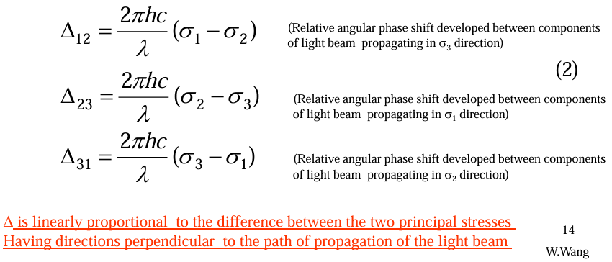

# Equipment And Specifications:

### Fixing of Model

The desired model is fixed using the apparatus besides and the load is applied

using load spindle. The model is fixed to spindle by a double clip and to the

lower cross arm by mounting. By slowly and carefully rotating the load spindle

the formation of isochromates can be observed.

### Linear and Circular Polariscope

A **linear polariscope** uses linearly polarized light to reveal isoclinic fringes, showing

principal stress directions in materials. It consists of a polarizer, stressed material,

and an analyzer that rotates to display fringe patterns. A **circular polariscope** uses

circularly polarized light to detect isochromatic fringes, revealing stress magnitude variations, with a quarter-wave plate and analyzer for light conversion. Both are used to analyze stress distribution and concentrations in transparent materials.

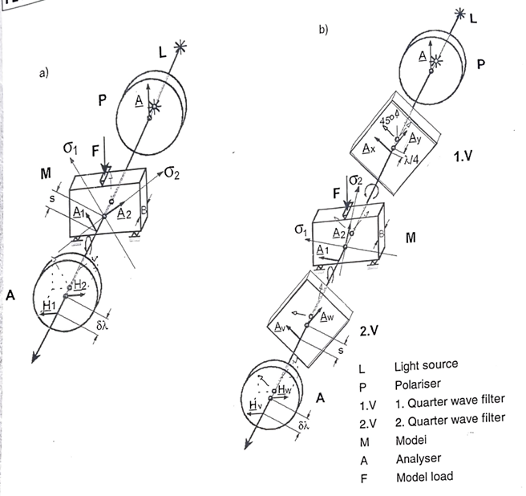

### Monochromatic Sodium Light

Monochromatic light has a single wavelength, produced by sources like lasers or LEDs, and is used in experiments like photoelasticity for clear, distinct fringe patterns. It ensures uniform interference effects. Polychromatic light contains multiple wavelengths and is used in photography and illumination. Monochromatic light simplifies stress analysis by avoiding overlapping fringes, unlike polychromatic light.

### Makrolon Model

**Makrolon** is a brand of polycarbonate plastic known for its high impact resistance, optical clarity, and durability. It is used in applications like eyewear lenses, automotive parts, and protective covers.

Density= 1.2e-9 Tonne/mm3

Young’s Modulus= 2600 MPa

Poison’s Ratio= 0.28

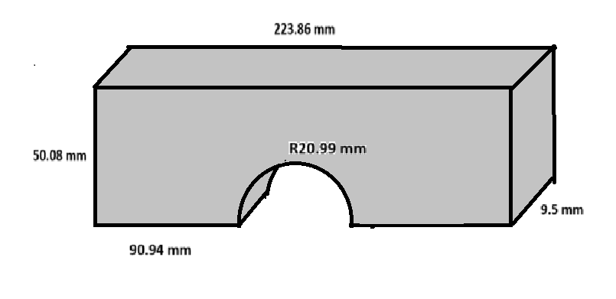

### Force Gauge or Spring Scale

A **force gauge** is a device used to measure force or load applied to an object. It typically features a dial or digital display that shows the force value, often used in photoelasticity experiments to measure forces applied to materials.

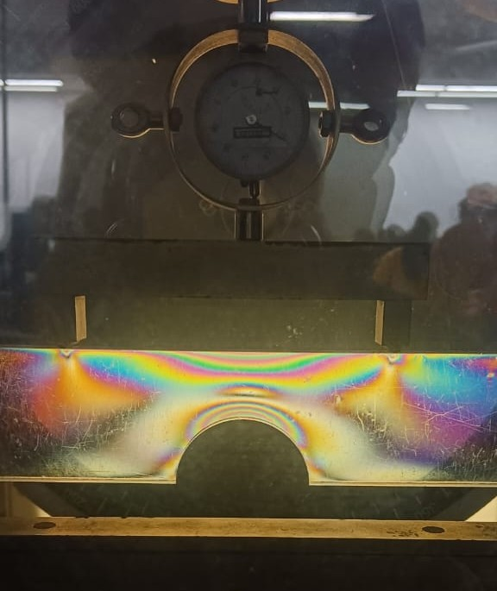

# Observations:

In this lab, a **Makrolon** material model was compressed by applying compressive forces of 0, 50, 100, 150, and 200 N, causing stress to develop within the model. The stress was observed using the principle of photoelasticity by viewing the compressed model under monochromatic light through a polariscope. Different fringes appeared on the model when viewed through an analyzer, and these fringes formed based on the internal stresses induced by the compression. The same observations were verified using a finite element analysis (FEA) simulation software called **Abaqus**.

### Abaqus

**Abaqus** is a versatile FEM-based simulation software by **Dassault Systèmes**, used in industries for linear and non-linear analyses. It handles complex material behaviors, dynamic simulations, and integrates with other tools. Abaqus offers robust pre-processing, simulation, and post-processing capabilities, making it essential for optimizing designs and reducing physical testing.

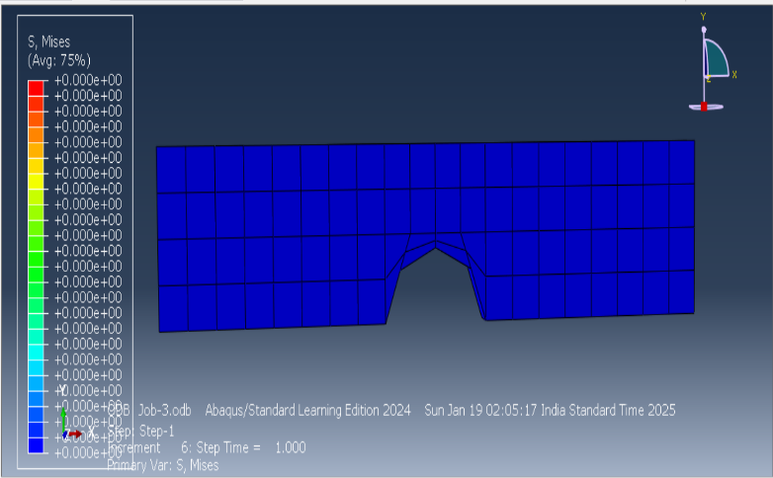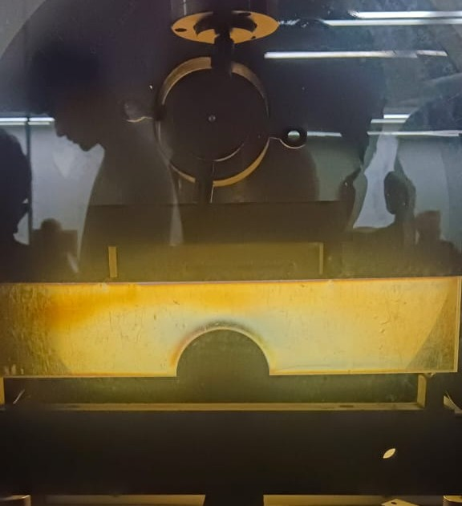

1. **0 N Force is apllied on the Model: Experimental Observation and Abaqus Stimulation**

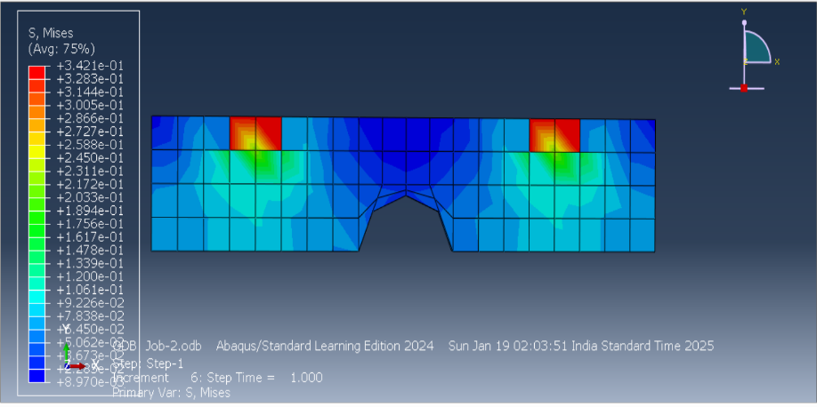

1. **50 N Force is apllied on the Model: Experimental Observation and Abaqus Stimulation**

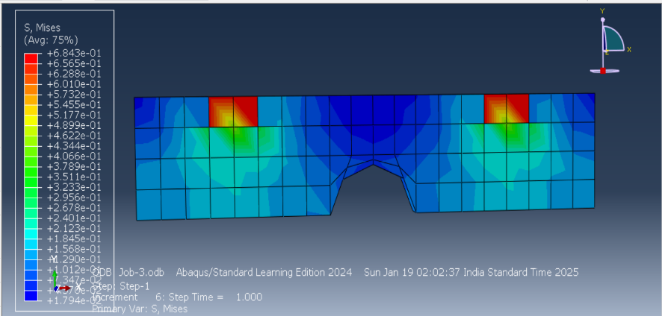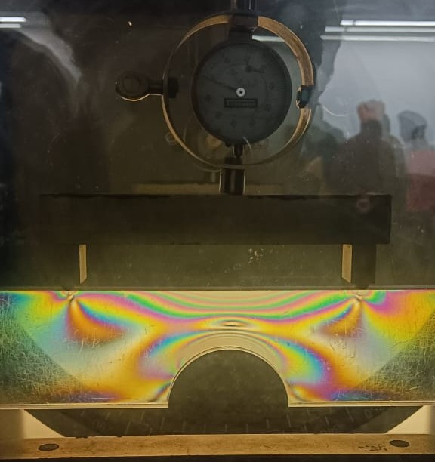

1. **100 N Force is apllied on the Model: Experimental Observation and Abaqus Stimulation**

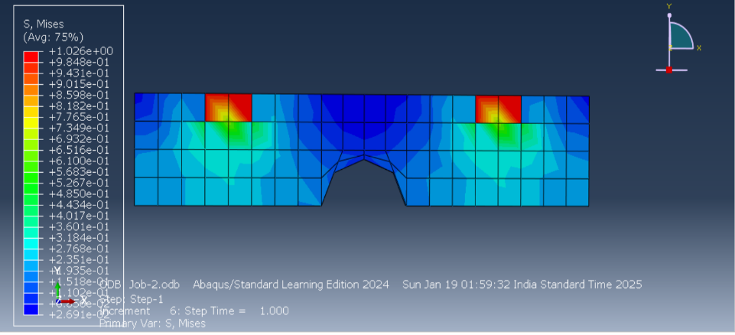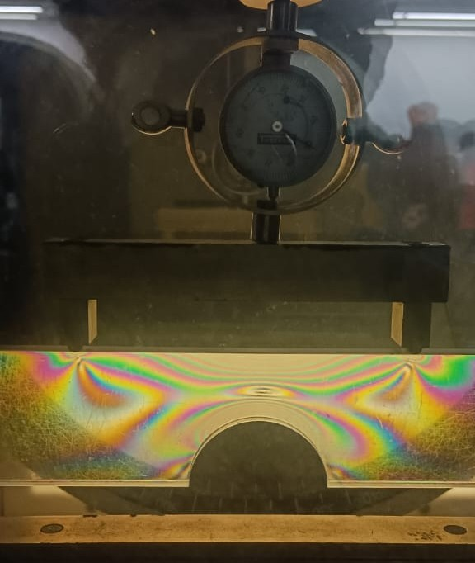

1. **150 N Force is apllied on the Model: Experimental Observation and Abaqus Stimulation**

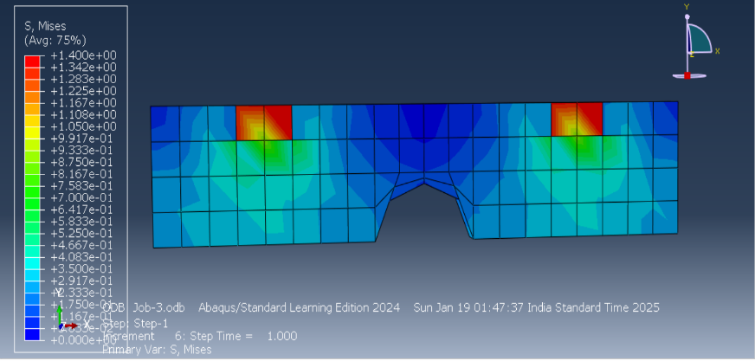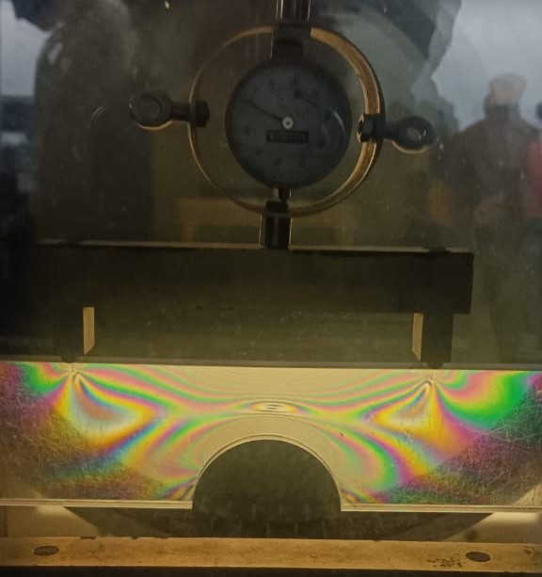

1. **200 N Force is apllied on the Model: Experimental Observation and Abaqus Stimulation**

# Comparision With Theory:

The comparison highlights several key points:

1. **Stress Distribution Accuracy:** According to elasticity principles and Hooke’s Law, stress distribution in materials was validated through photoelastic fringes and detailed stress distributions observed in Abaqus simulations.
2. **Material Behavior:** Theoretical elastic behavior, where stress is proportional to strain, was confirmed as fringe patterns increased with load, and FEA results matched the theoretical response.
3. **Stress Concentration and Singularities:** Theory predicts stress concentration at geometric discontinuities, corroborated by denser fringes in experiments and higher stress values in FEA simulations.
4. **Linearity of Load vs. Fringe Order:** A linear relationship between load and fringe order, predicted by theory, was observed experimentally and confirmed through FEA results.
5. **Polarization and Light Interaction:** The interaction of polarized light with stressed birefringent materials, producing fringe patterns, was demonstrated experimentally, with FEA accurately predicting corresponding stress values.

This comprehensive comparison affirms the consistency between theory, experimental observations, and FEA simulations.

# Conclusion And Discussion:

The photoelastic experiment effectively demonstrated the visualization of stress distribution in transparent materials under applied loads. The interference fringes observed under polarized light correlated directly with internal stress, confirming theoretical predictions of birefringence. The experiment also validated the accuracy of computational methods like FEA (e.g., Abaqus), showing agreement between fringe patterns and stress contours. This technique proved valuable in identifying stress concentration areas, which are critical for preventing material failure. By analyzing the varying refractive index, we identified high-stress regions prone to failure. Understanding these locations enables structural optimization by introducing design modifications such as holes, fillets, or chamfers, ultimately improving durability and reducing failure risk.

# Additional Discussion:

### Isotropic and Anisotropic Materials

Isotropic materials have identical properties in all directions. Their physical properties, such as refractive index, are uniform regardless of the direction of measurement. Examples include glass and metals. Anisotropic materials have direction-dependent properties. Their physical characteristics, like refractive index or conductivity, vary based on the direction. Examples include wood, crystals like calcite, and composites.

### Jones Vector and Matrix

The Jones vector is a two-component complex vector representing the polarization state of light, while the Jones matrix is a 2x2 matrix that describes how an optical element alters this polarization. By multiplying the Jones vector and matrix, the light’s polarization is transformed. Jones calculus is limited to fully coherent light and cannot handle partially polarized or depolarized light, which requires tools like Stokes parameters and Mueller matrices.

### Measuring Techniques:

#### Observation of Colour Pattern Method

The **Observation of Colour Pattern Method** in stress optics, or photoelasticity, analyzes stress distribution in transparent materials. Stress-induced birefringence causes light to split into polarized rays, creating interference patterns called fringes, which indicate stress levels. This non-destructive method is used in engineering, material science, and structural analysis to visualize and evaluate stress.

#### Compensator Method

The **Compensator Method** in stress optics measures stress distribution in transparent materials using photoelasticity. It employs a compensator to balance the optical path difference caused by birefringence in stressed specimens. By nullifying fringe patterns, the method precisely quantifies stress magnitudes and directions, aiding in structural analysis.

#### Analyzer Rotation Method

The **Analyzer Rotation Method** in stress optics analyzes stress distribution in transparent materials using polarized light. The material is placed between a polarizer and analyzer, and as the analyzer rotates, changes in light intensity reveal the birefringence caused by stress. This helps visualize stress directions and magnitudes, commonly used for materials like glass and plastics.

# Refrences:

* <https://en.wikipedia.org/wiki/Photoelasticity>
* <https://encyclopedia2.thefreedictionary.com/Photoelastic+Effect>
* <https://www.sciencedirect.com/topics/materials-science/photoelasticity>
* <https://depts.washington.edu/mictech/optics/me557/photoelasticity.pdf>
* <https://www.sciencedirect.com/science/article/abs/pii/0015056876900117>